CRUISE REPORT
Eco-FOCI’s GOA-IERP/LTL April 4-24, 2013
Cruise Number: DY1304 / FOCI Number:DY1304
Ship: NOAAShip Oscar Dyson

Area of Operations: Southeast Alaska
Depart: Seward, AK April 4, 2013
Return: Seward, AK April 24, 2013
Participating Organizations and Principal Investigators:

Dr. Phyllis Stabeno
NOAA – Pacific Marine Environmental Laboratory (PMEL)
7600 Sand Point Way N.E.
Seattle, Washington 98115-6439

Dr. Jeff Napp
NOAA – Alaska Fisheries Science Center (AFSC)
7600 Sand Point Way N.E.
Seattle, Washington 98115-0070

Dr. Suzanne Strom
Western Washington University
Shannon Point Marine Center
1900 Shannon Point Road
Anacortes, WA 98221

Dr. Calvin W. Mordy
Joint Institute for the Study of Atmosphere and Ocean
University of Washington
7600 Sand Point Way N.E.
Seattle, Washington 98115-6439

Dr. Ana Aguilar-Islas
Institute of Marine Science
335A Irving II
P.O. Box 757220
University of Alaska Fairbanks
Fairbanks, AK 99775-7220

Chief Scientist:
Dr. Nancy Kachel, NOAA/PMEL
Joint Institute for the Study of Atmosphere and Ocean
University of Washington
7600 Sand Point Way N.E.
Seattle, Washington 98115-6439
206-526-6780
Nancy.Kachel@noaa.gov

Personnel:
Dr. Nancy Kachel  Dr. Suzanne Strom  Dr. Ana Aguillar-Islas  Dr. Peter Proctor  Dr. Dean Stockwell  Dr Marie Seguret  David Kachel  Sigrid Salo  Lisa DeForest  Morgan Busby  Jay Clark  Christina Jump  Kelly Bright  Morgan Ostandorf | M  F  F  M  M  F  M  F  F  M  M  F  F  F | USA  USA  USA  USA  USA  USA  USA  USA  USA  USA  USA  USA  USA  USA | PMEL/UW  WWU  UAF  PMEL/UW  UAF  UAF  PMEL  PMEL  AFSC  AFSC  AFSC  AFSC  WWU  PMEL/UW
Objectives of Cruise:
Ecosystems & Fisheries-Oceanography Coordinated Investigations (EcoFOCI) is an effort by National Oceanic and Atmospheric Administration (NOAA) and associated academic scientists. Eco-FOCI’s goal is to understand the effects of abiotic and biotic variability on ecosystems of the North Pacific Ocean and Bering Sea. This cruise is in support of research sponsored by NOAA’s North Pacific Climate Regimes & Ecosystem Productivity Program, the North Pacific Research Board (NPRB), and PMEL/AFSC base. The research conducted on this cruise is part of the NPRB’s Gulf of Alaska- Integrated Ecosystem Research Program (GOA-IERP) Lower Trophic Level Project (LTL) component. The Program intends to increase our understanding of how five target fish taxa (walleye pollock, Pacific cod, arrowtooth flounder, sablefish, and Pacific Ocean perch) pass through the larval gauntlet and eventually recruit as adults. The Lower Trophic Level Component is one of four major components to the overall project (Lower Trophic Levels, Middle Trophic Levels, Upper Trophic Level, Modeling. An additional major goals of the overall project s to compare and contrast the mechanisms responsible for recruitment of fish species between the eastern and northern portions of the Gulf of Alaska. While many mechanisms controlling on shelf and cross-shelf fluxes in the two regions are likely similar, we are also finding distinct differences between the narrow shelf of EGOA and the broader down welling dominated shelf of WGOA. Our four primary objectives for each region are to quantify, compare and contrast (1) the timing and magnitude of the different cross-shelf exchange mechanisms, using an extensive suite of oceanographic (i.e. moorings, drifters, cruises) and atmospheric measurements, (2) how these physical mechanisms influence macro and micro-nutrient availability, and in turn the distribution, timing and magnitude of phytoplankton productivity, and (3) how both transport and primary productivity control the distribution, productivity, and fate of both zooplankton and ichthyoplankton, (4) how observation in 2013 contrast to those in 2011, which was a year without a significant spring bloom in Southeast Alaska.

Cruise Itinerary
The NOAAShip Oscar Dyson departed Seward, AK at 13:00 on 4 April 2013for operations in Southeast Alaska.
We conducted a test CTD cast at the long-term station, GAK1 at the mouth of Reserection Bay The next day, 5 April, we conducted a test trace-metal cast and neuston and bongo net tows at a station en route to the Southeast sampling grid. We began operations at SEM20, at the north end of the SE grid on the morning of 6 April 2013.The stations sampled during DY1304 are shown in Figure 1. At SEM0 we encountered high fluorescence values indicating the spring bloom had begun. The transects across Chatham Strait (CS, Cross Sound (XS), Cross Sound Trough (XST), Fairweather Grounds (FG) and Yakutat Trough (YTX) were not part of the GOA_IERP standard grid. Not all stations were on CTD transects, but were taken in the morning for productivity experiments.
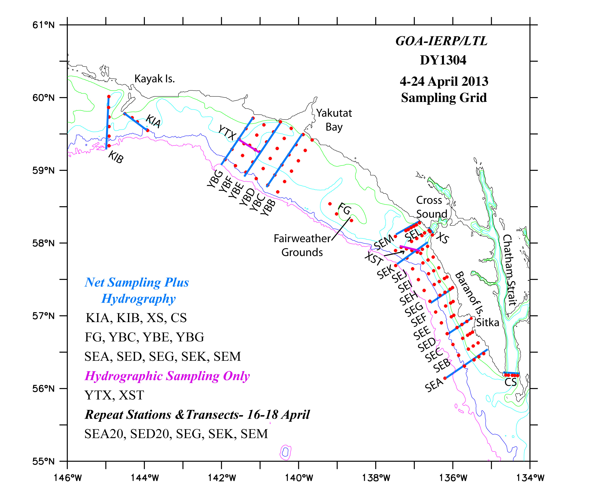
Figure 1. Sampled Stations on DY1304, with operations indicated.

Figure 2 shows the values of the flow-through fluorescence along most of the cruise track. We encountered high levels of chlorophyll intermittantly as we worked our way south until we got as far south as Sitka Sound. After that, we saw the spring bloom at most continental shelf stations. After occupying the 5 staions on the Chatham Strait line, we went out to SEA40, which is a station sampled on the LTL, and then went back to SED20 to sample with a multinet. After that we re-occupied the SEG, SEK and SEM lines, making CTD casts and same more trace-metal casts under full spring bloom conditions. SEK30 was added to that line. Severe weather caused us to go into Cross Sound for ~6 hours
. 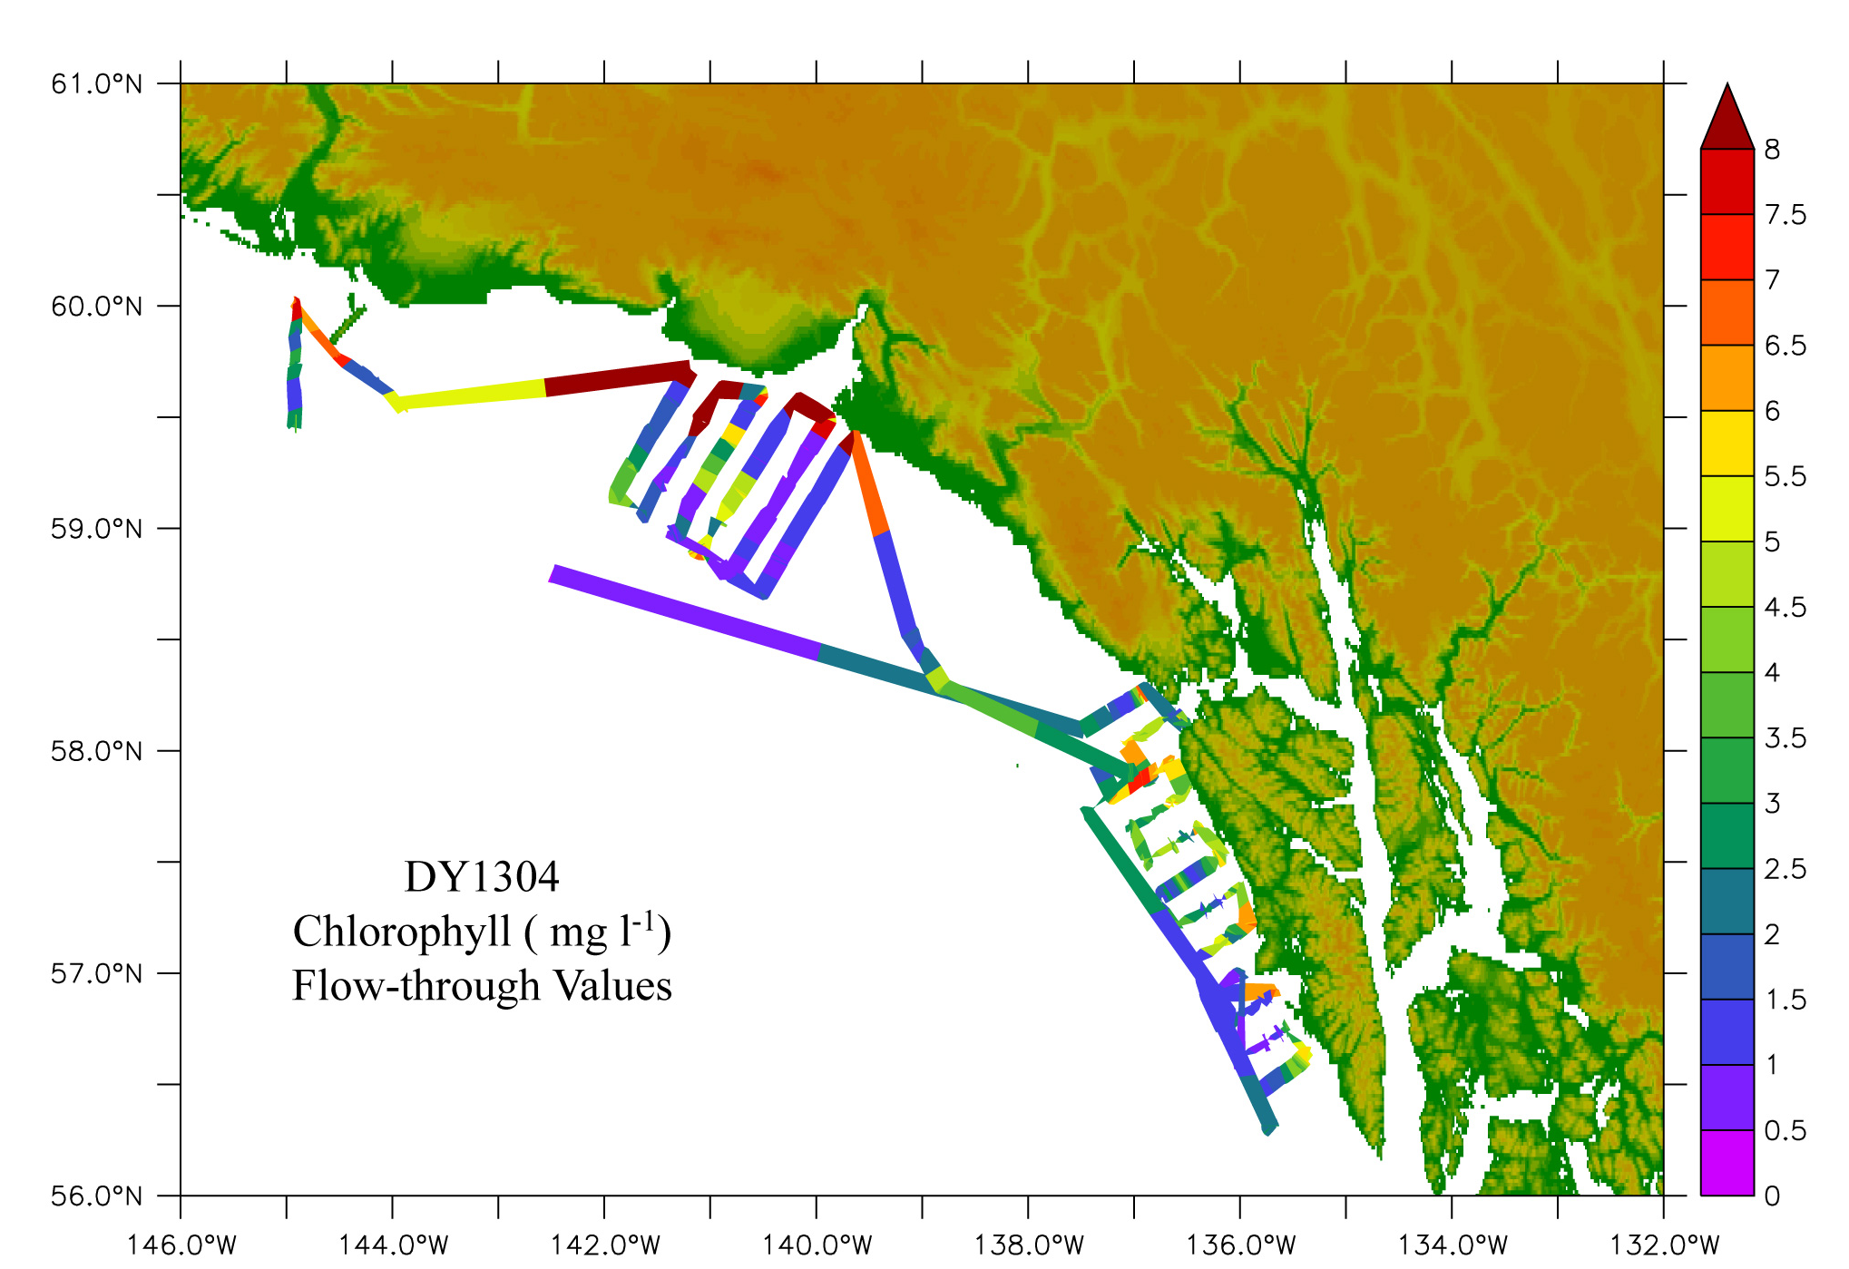
Figure 2. DY1304 cruise track with values of flow through Fluorescence.

On the transits northward, the trace-metal fish was deployed successfully several times. The location of samples taken from the fish are shown in figure 3.
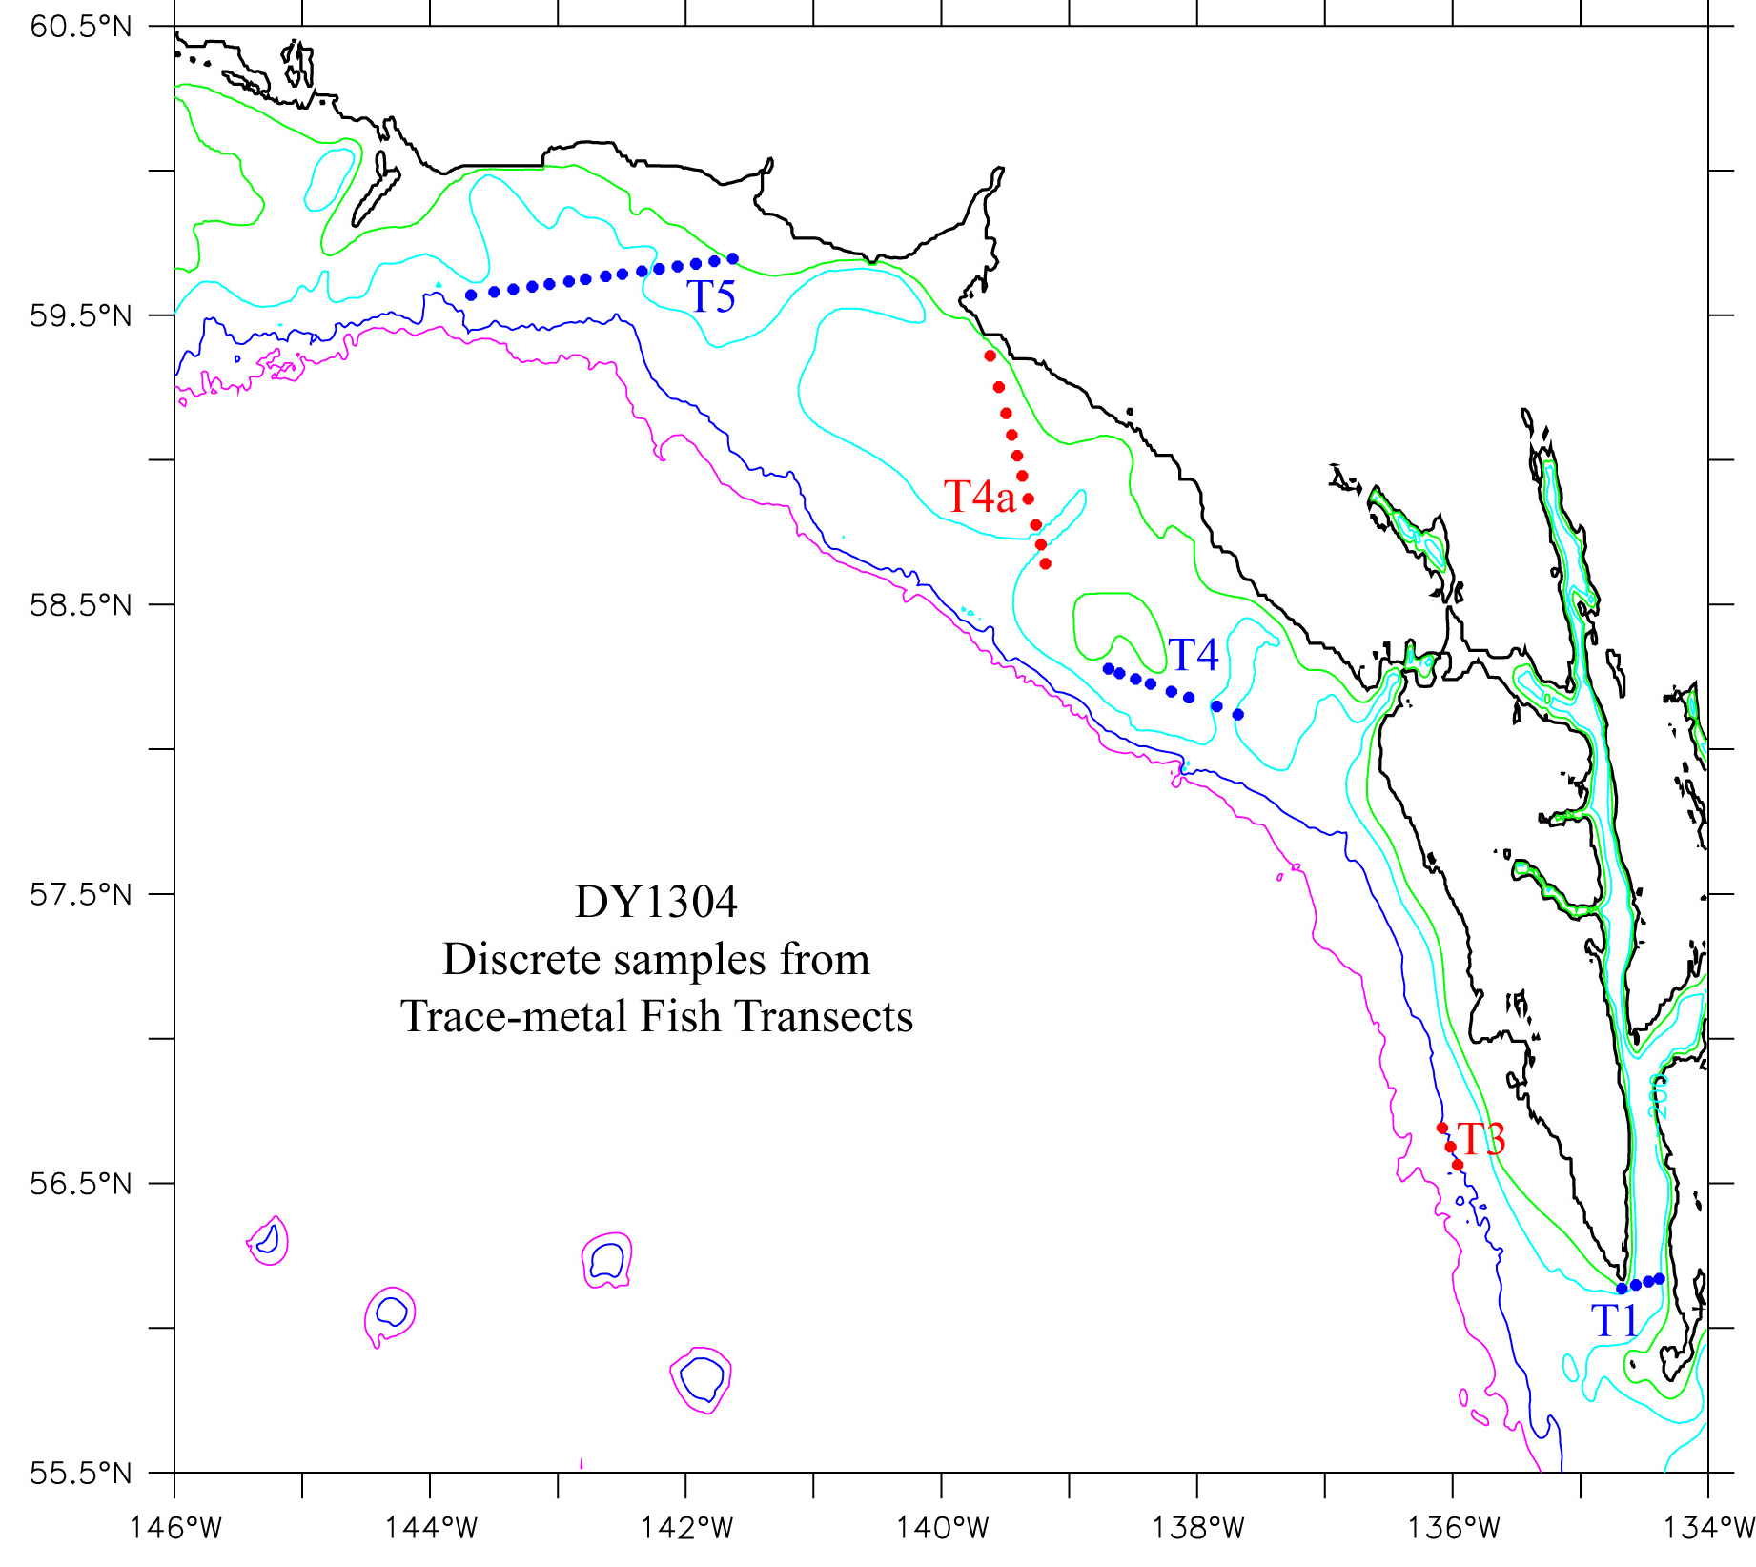
Figure 3. Locations of trace-metal samples taken from surface waters using a towed fish.

After we finished the SEK line for the second time, the weather improved, and remained excellent until we approached the end of the Yakutat Bay grid. Another multinet tow was conducted in Spencer Trough, and two more on the Yakutat grid. In the time remaining, we were able to occupy the KIA stations and an extended version of the KIB transects. The ship returned to Seward, Alaska on 24 April, 2013. The summary of operations, sampling, the AFSC cruise summary, and an event log can be found in the Appendix.

Sampling and Operations
At all but a few stations MARMAP bongo and Sameoto neuston net tows were made to collect zooplankton and larval fish. Multinet tows were conducted at five stations. On 11 of the sampling lines, only net tows occurred. On another 12 transects CTD casts accomplanied the net tows, with samples taken for oxygen, fractionated chlorophyll, nutrients, and salinity. On two of the transects, CST (Cross Sound Trough) and YTX (across Yakutat Trough), only CTD casts were taken. Note that Cross Sound Trough is usually referred to as Spencer Trough. Additional water samples were taken for phytoplankton productivity experimetns and molecular analysis. Water was collected from the Niskin bottles for experiments measuring the growth and production of phytoplankton. Trace metal samples were taken by two methods: bottles samples, and a trace metal fish towed away from the side of the ship that collected samples underway. During the course of the cruise seven ARGOS satellite-tracked buoys drogued at 40m were deployed.
Hydrographic Measurements- Nancy Kachel, Peter Proctor, David Kachel, and Sigrid Salo
The conductivity, temperature and depth (CTD) casts were made with the Dyson’s CTD with SeaBird 911 with dual temperature and conductivity sensors. Attached to the CTD were a transmissometer (beam attenuation), a WetLabs ECO chlorophyll fluorometer, a Biospherical Instruments QPC2300-HP Photosynthetically Activated Radiation (PAR) sensor, and one SBE43 oxygen sensors.
a. Salinity Measurements
A total of 62 salinity samples were taken to be analyzed at PMEL, as a means of calibrating the conductivity sensors on the CTD and flow-through systems.
b. Nutrient Measurements
Nutrient samples were collected from the Niskin bottles in acid-washed 35-ml polyethylene bottles after three complete seawater rinses and frozen in a -80°C freezer for analysis after the cruise at PMEL. Nutrients are to be analyzed at PMEL using a continuous flow analyzer (CFA) using the standard analysis protocols for the WOCE hydrographic program as set forth in the manual by L.I. Gordon, et al (2000). Approximately 950 samples from CTD casts and another ~90 samples from trace metal casts were collected for analysis of phosphate (PO₄-), nitrate (NO₃-), nitrite (NO₂-), orthosilicic acid (H₄SiO₄), and ammonium (NH4+).
c. Oxygen Measurements
Approximately 120 oxygen samples were taken to calibrate the SBE43 oxygn sensor. Winkler titrations were conducted according to WOCE protocols. On each cast, the number of samples and the depths sampled were dependent on the oxygen profile from the CTD. In deep water, samples were typically collected at every depth below 100m. On the shelf, one sample per CTD cast was usually collected either from the Niskin in the upper layer, or in the bottom mixed layer. End point determinations of the Winkler titration were determined poteniometrically. Thiosulfate was standardized for each batch of sample titrations, and blanks were measured periodically during the cruise.
e. ARGOS Satellite-Tracked Drifters
On seven occasions during the cruise we deployed ARGOS drifters drogued at 40m: two at the mouth of Cross Sound, at different times, one at SED20 on the slope off Baranoff I., two at SEK5 in Spencer Trough (one of which failed to transmit) and two off Yatutat Bay (see figure 4). Olav Ormsted deployed two more drifters in Chatham Strait from another verssel during the same time period. Movies of the drifter tracks are updated daily at the website.
For the Baranof Island Area see: http://www.pmel.noaa.gov/foci/visualizations/drifter/csou2013.html
For the Yakutat Bay Area see: http://www.pmel.noaa.gov/foci/visualizations/drifter/csou2011.html

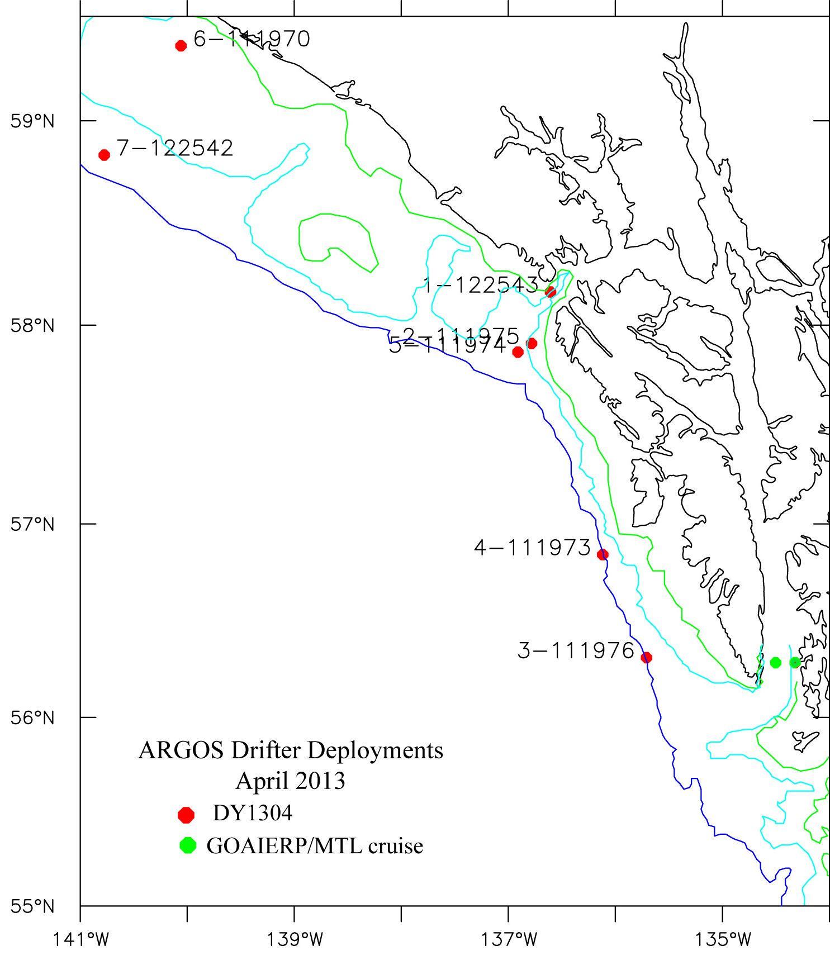
Figure 4. ARGOS drifter deployments during the DY1304 cruise. Two drifters were deployed in Chatham Strait by Olav Ormsted on a GOA-IERP MTL cruise during the same period.

Ichthyoplnkton and Zooplankton Sampling-
Morgan Busby, Lisa DeForest, Jay Clark and Christina Jump
One hundred and fifteen neuston net tows (0.500 mm mesh) and 116 MARMAP bongo tows using 60cm nets were made at GOAIERP grid stations shown in Figure 1. Four Multinet tows were made to determine the vertical distribution of fish larvae. These data are necessary for proper construction of the GOA IERP larval transport models being developed by the Modeling Component (Gibson and Hinckley). To supplement that effort several MARMAP bongo tows were made to depths of 400-600m.
The contents of the net tows were preserved in 5% Formalin and will be examined for ichthyoplankton. Larvae of one of the five target species (sablefish) were found in the neuston. A SBE 49 FastCat or 19+ SeaCat was attached to wire, just above the bongo frame to allow the depth of the tow, temperature, and salinity to be measured. In water deeper than 200m, tows were made generally to 200m although tows to between 400 and 600 m were made at a few slope and trough stations. Samples were preserved with 5% buffered Formalin. Prior to preservation, approximately 50 eggs and 1,900 larvae were removed from net two of the 60 cm bongo and preserved in 100% ethanol for genetic studies. In the 60 cm bongo samples sorted at sea, rockfish larvae (Sebastes spp.) were the most abundant taxa followed by arrowtooth flounder (Atheresthes stomias) and sablefish Anoplopoma fimbria. Other species present include walleye pollock (Theragra chalcogramma), Pacific cod (Gadus macrocephalus), and Pacific sand lance (Ammodytes personatus). Walleye pollock and Dover sole (Microstomus pacificus) were the most commonly collected fish eggs. Neuston tows were dominated by greenlings (Hexagrammos spp.). All rockfish larvae will be sent to the TSMRI laboratory for identification using genetic barcoding methods. The remaining fish will be used for genetics testing by the Recruitment Processes Program of the AFSC. The unexamined side of the 60 cm bongo will be sent to the Polish Plankton Sorting and Identification Center in Szczecin Poland for identification of all fish eggs and larvae. The other side of the 60 cm (the one where fish larvae were removed) plus one side of the 20 cm frame will be sent to R. Hopcroft (University of Alaska, Fairbanks) for identification and quantification of all zooplankton.

Phyto- and microzooplankton sampling –
Suzanne Strom and Kelley Bright (Western Washington Universtity)

Chlorophyll Sampling
Chlorophyll samples were collected from all major hydrographic lines, as well as at selected stations along ‘feature based’ lines (e.g. Cross Sound, Chatham Strait). At a given station samples from at least 6 depths (0-50 m) were collected to provide an estimate of integrated euphotic zone chlorophyll content. All water samples for chlorophyll analysis were size-fractionated using a tiered system of filters to generate estimates of chlorophyll in the <20 µm and >20 µm size fractions. Chlorophyll samples (in total a bit over 1,000 separate filters) were extracted and analyzed fluorimetrically on board the vessel.
Phytoplankton Identification and Carbon Biomass Estimates
Accompanying samples (~50) for identification of phytoplankton taxa and estimation of carbon biomass were collected from a subset of the above lines, generally from 10 m depth only. Two types of samples for microscopic analysis of phytoplankton were collected: glutaraldehyde-preserved samples for epifluorescent detection of the smallest (<20 µm) cells; and formalin-preserved samples for detection and identification of larger cells such as diatoms. Approximately 100 samples (preserved in Lugol’s iodine solution) for identification and quantification of microzooplankton were collected from lines SEA, SEG, SEK, YBC, and YBG, as well as from selected additional stations. In general samples from 4 euphotic zone depths (10-50 m) were obtained, to allow estimation of depth-integrated microzooplankton biomass.
Photosynthesis Rates
Photosynthesis – irradiance experiments were conducted on 14 different dates. In all but one case these comprised paired experiments utilizing water collected from two different euphotic zone depths (thus a total of 27 P-E curves was generated). All samples for analysis of photosynthetic response were size-fractionated during post-incubation filtration, allowing separate estimation of photosynthetic parameters for the <20 and >20 µm phytoplankton size fractions as well as the total community response.
Light Absorption and Scattering
On several different dates, light absorption and scattering data were collected over several-hour periods from near-surface depths with a WET Labs AC-S (multi-wavelength) in situ spectrophotometer. This data collection utilized the Dyson’s flow-through seawater system during extended ship transit periods.
Summary of Sample types and experiments from the cruise by the Strom Group:
- 27 experiments measuring phytoplankton productivity in both the large (>20 µm) and small (0.7 to 20 µm) size fractions.
- 48 Glutaraldehyde fixed and DAPI stained samples made into slides for counting and sizing small (<20 µm) phytoplankton and heterotrophic flagellates.
- 46 Formalin fixed samples for counting and sizing diatoms and large phytoplankton
- 102 Acid Lugol’s fixed samples for counting and sizing microzooplankton (e.g. dinoflagellates greater than 20 microns and all ciliates).
- 500+ water samples size fractionated to capture the >20 µm fraction and the 0.7 to 20 µm fraction for >1000 chlorophyll estimates.
Effects of Iron Size Classes on Productivity and Community Structure –
Ana M. Aguilar-Islas, Dean Stockwell

Trace Metal Sampling

Filtered seawater and suspended particulate samples were collected using trace metal clean techniques. Samples will be processed and analyzed onshore for the determination of several size fractions and chemical species of iron. The overarching goal of this work is to better understand how oceanographic processes in the Gulf of Alaska affect the distribution of different forms of iron. Because different species of iron vary in their biological reactivity, this work will contribute towards an improved understanding of the factors that affect the primary productivity of this important region. Collaboration with other GOA-IERP lower trophic level (LTL) components will serve to place the Fe work into an ecosystem context.
a. Vertical Profiles
Filtered seawater and suspended particles were collected at 16 stations from various depths (15 - 500 m) using UAF vanes. The stations sampled were TEST (CTD2), SEK20 (CTD18), SEK5 (CTD21), SEG20 (CTD26), SEG10 (CTD28), SEG5 (CTD30), SEA20 (CTD39), SEA5 (CTD40 and 42), SEA40 (CTD52), SEK30 (CTD65), YBC50 (CTD74), YBC30 (CTD78), YBC10 (CTD80), YBE40 (CTD86), KIA4 (CTD101), and KIBa (CTD107). A total of 244 samples were collected; 62 for suspended particles; 62 for for dissolved iron; 62 samples for nutrients; 40 samples for photosynthetic efficiency; and 18 samples for organic iron speciation. Water column sample collection proceded smoothly during the cruise. Initial setback with the new conducting wire, which has a wider diameter than the wire it replaced, were overcome by on-board modifications to the equipment. The ship’s engineers were helpful in this matter and contributed to the successful deployment of the UAF vanes.
b. Surface Transects
Surface seawater samples were collected during 5 transects (Figure X) using a towed trace metal clean system and on-deck pump. A total of 132 samples were collected; 41 for dissolved iron; 41 for nutrients; 41 for photosynthetic efficiency; and 9 samples for organic iron speciation. The towing point on the Dyson (starboard A frame) positions the towed equipment further aft than it would be ideal. This further aft position reults in the towed equipment experiencing a drag that brings it closer than desireable towards the ship. Any potential contamination from the ship is unknown at this point, but will be determined after analysis. Additionally, the surface sampling equipment was damaged on deck during a storm, and onboard repairs were not possible. A backup system was used to collect most surface transect samples. This backup towing equipment is much lighter and rides closer to the surface when towed, which could contibute to potential contamination. Several modifications to the equipment were tested to make it tow further from the ship. The ship’s crew and engineers were helful with suggestions for these modifications.
c. Photosynthetic Efficiency and growth Experiments - Dean Stockwell (UAF)
A fluorometer that measures Fv/Fm was used to investigate the surface chlorophyll from samples taken from the flow-through seawater system on about 40 of the transit lines. Fv/Fm is a parameter widely used to indicate the maximum quantum efficiency of Photosystem II. This parameter is widely considered to be a sensitive indication of plant photosynthetic performance with healthy samples typically achieving a maximum Fv/Fm value of approx. 0.85. Values lower than this will be observed if a sample has been exposed to some type of biotic or abiotic stress factor, which has reduced the capacity for photochemical quenching of energy within the PSII. Fv/Fm is presented as a ratio of variable fluorescence (Fv) over the maximum fluorescence value (Fm).
Samples were typically taken during those times when the Dr. Aguillar-Islas had the trace metal fish in the water, so the effect of iron concentration on photosynthesis performance could be investigated. The system was also run on some of the longer transits. In addition to taking samples from the flow-through system, another ~200 discrete samples were taken from the trace-metal fish, and from the trace-metal bottles on the CTD wire during the Fe casts, and various samples taken from the CTD Niskin bottles usually in conjunction with the iron sampling.
In addition to the above sampling, eight on-deck incubations for growth experiments were conducted in an attempt to look at photosynthesis in the surface waters for comparison to the fluorescence studies described above.

APPENDIX

Table 1. Summary of Gear Deployed
Operation Tows
60cm bongo (60BON) 116
with a Seabird FastCAT CTD (CAT) 116
Semeoto Neuston (NEU) 116
0.3m² Multinet 4
CTD casts 112
Trace Metal (UAF vanes)/CTD casts 18
Trace Metal transects 5

Table 2. Summary of Samples Collected
Samples Collected Tows Number
larval fish and eggs 116 ~1900
SeaBird FastCat CTD (CAT) 116
Quantitative tow preserved in formalin (QTowF) 116
Formalin preserved samples for diatoms and large phytoplankton 46
Acid Lugol’spreserved samples for Microzooplankton
and large dinoflagellates 102
Nutrient Samples ~940
Chlorophyll Samples ~1100
Fractionated Chlorophyll Samples ~500
Water for Phytoplankton for growth experiments 27
Salinity samples 62
Disolved Oxygen 48
Trace Metal samples from Casts ~90
Trace Metal samples from towed fish 42
Table 4. CTD Transect Lines and Trace-Metal casts

CTD Line ID  (orientation) | Description | Cast # (offshore to onshore) | Trace Metal Cast Nos.
SEM1 | North line of SE grid | 3-8
XS (N-S) | Cross Sound | 11-9
XST | Spencer Trough | 17-13
SEK1 | S. of Cross Sound | 19-23 | 18 ,21
SEG1 |  | 27,29,31-33
SED | Sitka | 37-34 | 54
SEA | South Line of SE grid | (51),40-41,43,45 | 39,42,44, 52
CST | Chatham Strait | 50-46
SEG2 | repeat | 60,58-55 | 56
SEK2 | repeat | 66,64-61
SEM2 | repeat | 72-67
YBC | S. of Yakutat Bay | 75-77,79,81-82 | 74,78,80
YBE | Yakutat Bay | 84-85,87-90 | 86
YBG | N. of Yakutat Bay
YTX (N-S) | Yakutat Trough | 95-91
KIA (S-N) | SE. from Kayak I. | 102-105 | 101
KIB(S-N) | N-S west of Kayak I. | 112-108,106 | 107
FG | Fairweather Grounds

Table 5. Event Log for Cruise DY1304
(See Accompaning file: DY1304_EventLog.xlsx)

